**Coursework 1 Design Document**

# Introduction

In this design document, we will be detailing all the research and design choices that was made to create our models and model showcase for our design challenges.

# Design Challenge 1

Design Challenge 1 Specification:

In the design challenge specification, it says “You have been chosen to exhibit in the 100th anniversary of the virtual door expose! We need you to design and build a door to showcase for the event. I know it is short notice, but we need your best work. If it was possible to interact with the door and was accompanied by some sounds that really bring out the door’s personality, I think you could win!”

For this specification, I have decided to take my approach on this Challenge is by creating a door from the past.

User Story Map:

After brainstorming some potential ideas, I decided to come up with the idea of making a castle door for this challenge. First things first, I decided to expand these ideas with a user story map (shown below).

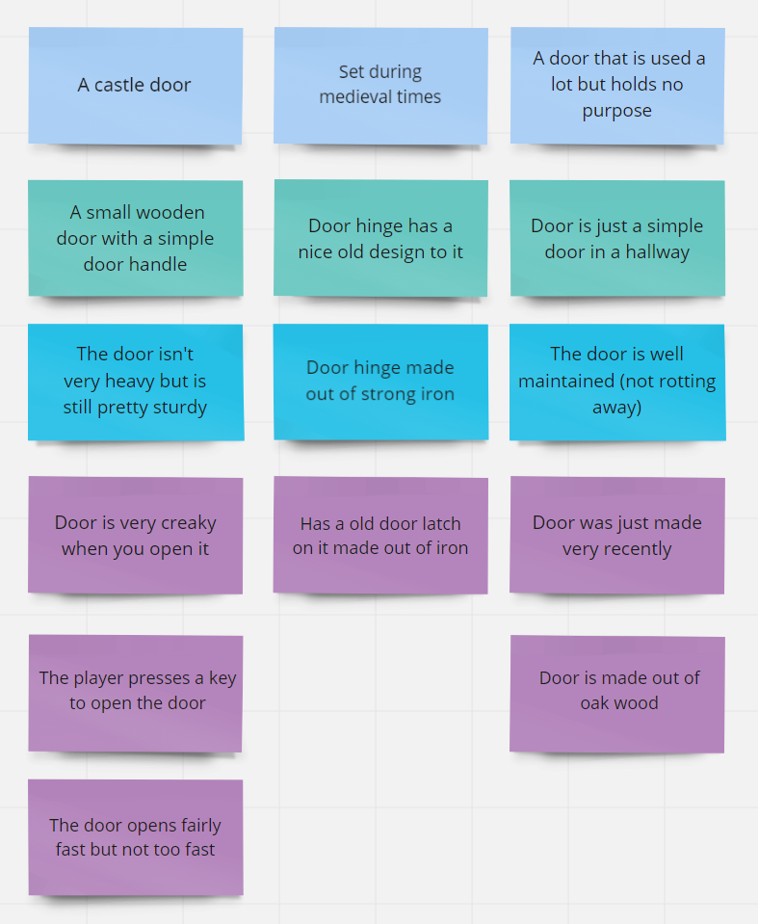

This story map helped me narrow down the specifics of what I want my door to be for my challenge.

Moodboard:

Next, I decided to look for some ideas for the visuals of my door. Using the expanded ideas from the User Story Map, I came up with this moodboard showcasing the visual ideas for my door.

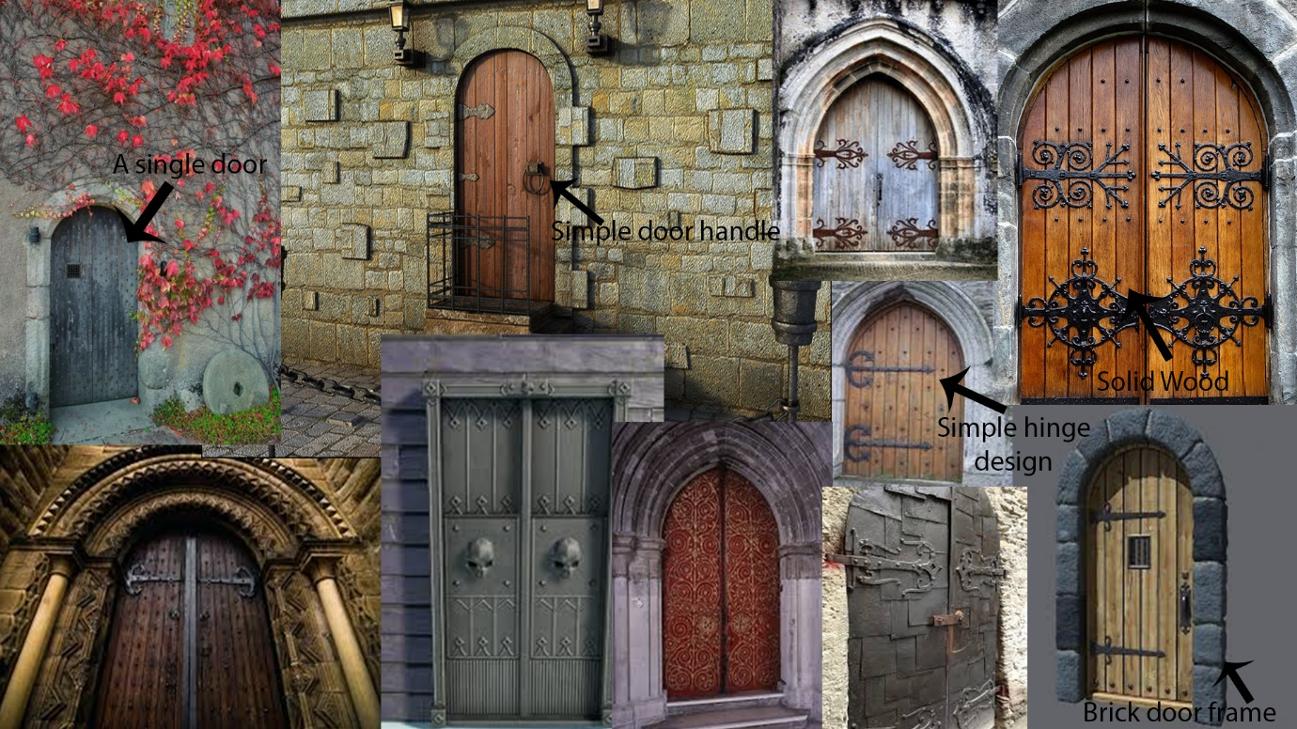

After evaluating the different types of castle doors, I finally came up with the idea to make 1 small wooden door with a simple door handle and a not too complex design for the hinge.

# Design Challenge 2

Design Challenge 2 Specification:

For this Design Challenge, I was tasked with interviewing a fellow student

# References Design Challenge 1

Door Moodboard:

<https://static.artfire.com/uploads/mfs/items/97/7e/large/977e7ba0eac4b7403d7b87d48a41b2af516b50b2aa76a750d5bd6e295f90085d.jpg>

<https://i.pinimg.com/originals/fc/91/a4/fc91a4a46083566e26f97b55bb7eaf27.jpg>

<https://i.pinimg.com/236x/9d/de/29/9dde29d0e2c38778ab37096862338706--castle-doors-blue-doors.jpg>

<https://preview.free3d.com/img-dev/2017/04/1761058959432615692/jmhvtv1f-900.jpg>

<https://i.pinimg.com/236x/b6/b8/81/b6b88135026bf5d5b194aa6a3e25eec9--kids-clubhouse-castle-doors.jpg>

<http://everywear.me/wp-content/uploads/2018/01/castle-door-castle-doors-by-castle-doors-and-windows.jpg>

<https://vignette.wikia.nocookie.net/planet-coaster/images/2/23/Planet_Coaster_-_Gothic_Castle_Door.png/revision/latest?cb=20171014191906>

<https://www.britainexpress.com/images/attractions/editor/Crathes-Castle-8538.jpg>

<https://www.stgeorges-windsor.org/wp-content/uploads/2017/08/Gilebertus450.jpg>

<https://storage.needpix.com/rsynced_images/castle-475413_1280.jpg>